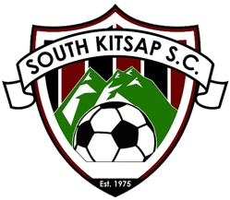 | South Kitsap Soccer Club | 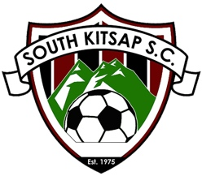

South Kitsap Soccer Club is seeking sponsors for the 2023 soccer season. Established in 1975, SKSC is a non-profit organization that is affiliated with U.S. Youth Soccer, Northwest Sound Youth Soccer Association (NSYSA), U.S. Club Soccer (through the SK United program), and the Washington State Youth Soccer Association. SKSC fields over 70 teams each season, composed of approximately 850 players, ages 4 through 18. Players participate in either club-level (recreational) play or they can opt to pursue competitive/premier-level play through the SK United program. SKSC relies on the support of over 150 volunteer coaches, team managers, and support staff each season.

SKSC is committed to providing a fun and positive soccer program for the youth of South Kitsap and surrounding communities year-round. SKSC’s goals are to foster not only a love for soccer and the development of skilled athletes, but to help players develop character traits that will prepare them for adulthood and provide them with opportunities in life. Teamwork, sportsmanship, commitment, confidence, and unrelenting effort are some of the core-tenets of our program.

In addition to the club’s commitment to developing players, SKSC facilitates training and licensing for coaches and referees, provides equipment and uniforms, offers specialized camps in the summer and winter and maintains dozens of fields for all practices and games. These services are funded through registration fees and community sponsorships and are provided through the efforts of un-paid, 100% volunteer staff.

The South Kitsap Soccer Club serves an area that is in need of sponsorships to help provide financial aid to children who cannot afford to cover the registration fees to play soccer. Sponsorships received will also help to defray the cost of equipment, uniforms, training, field rentals and referees. SKSC works diligently every year to keep fees at the lowest level possible, but rising league fees, insurance costs, field rental fees, and other expenses make it difficult to set fees that are affordable across all income-levels.

Sponsorships can start at any dollar amount and promotional opportunities are available starting at $250. Please see the attachment for descriptions and benefits received at each level. Your contribution is not only tax deductible but will also expose your business to a large number of soccer families, friends, coaches and trainers. Our club appreciates your consideration of our request. Your sponsorship will be recognized and appreciated for many years to come.

Thank you in advance for your consideration,

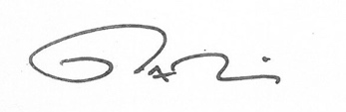

Matthew McDaniel, VP of Premier, SK United

South Kitsap Soccer Club
Sponsorship Levels

SKSC Supporter: $250-$1,499
- Organization's name appears on sponsorship page of the Club's website with link to your organization’s web site.
- Sponsoring organization receives plaque from Club.

SKSC Foundational: $1,500-$4,999
- Sponsor’s logo is featured on the home page of the club website, and on feature banners displayed on home-fields and at club events.
- Sponsor receives a framed jersey for display.

SKSC Developer: $5,000-$9,999
- Organization's name appears on sponsorship page of the Club's website with link to your organization’s web site.
- A banner ad for the sponsor’s organization will be displayed on home page of Club website.
- Sponsoring organization receives plaque from Club.
- Sponsor's logo will be printed on SK United practice jerseys.
- Sponsor’s organization is featured on banners displayed on home-fields and at club events.
- Sponsor’s logo is painted on the SKSC equipment locker at Veterans Memorial Park.

SKSC Legacy: $10,000 and above
- Organization's name appears on sponsorship page and home page of the Club's website with link to your organization’s web site.
- Sponsor’s organization is featured on banners displayed on home-fields and at club events.
- Sponsor’s logo will be printed on the front of all SK United Game-Day Jerseys
- Sponsor’s logo is painted on the SKSC equipment locker at Veterans Memorial Park and applied to the SK United equipment trailer.

Interested in helping our kids but not able to commit to a larger amount? You can choose to sponsor the club’s purchase of specific training items which will be used by our coaches and players. Simply select one or more of the items below:

- A pair of training goals (foldable “pugs” for practices): $75.00
- Training “pinnies”- mesh jerseys used to split players into colored teams at practices: $50.00
- Soccer balls (NFHS approved game ball): $30
- Training cones (25): $20.00
- First aid kits and refill supplies: $50.00
- Team benches: $75.00
- Shelter/canopy: $125.00
- Field marking paint: $150.00

South Kitsap Soccer Club
Sponsorship Form

Sponsor Name:
Contact Name:
Street Address:
City: | State: | Zip:
Phone Number: |  | Fax Number:
Email Address:
Company Web Site:

Pledge Information:

I wish to sponsor the South Kitsap Soccer Club in the amount of:

$ _____________________________

Signature: _________________________________________ Date: _______________________

Please make checks payable to:

South Kitsap Soccer Club
Attn: Sponsorship Committee
PO Box 23
Port Orchard, WA 98366

South Kitsap Soccer Club Tax ID # 91-1169887

